(Неделя 2)
SENTENCE STRUCTURE (2)
There are four kinds of sentences in English: (I) simple, (2) compound, (3) complex, and (4) compound-complex. Now we are going to focus on simple sentences.
A simple sentence is a sentence that has one subject-verb pair. The subject in a simple sentence may be compound:
e.g. My brother and I are twins.
The verb in a simple sentence may be compound:
e.g. They walked and talked.
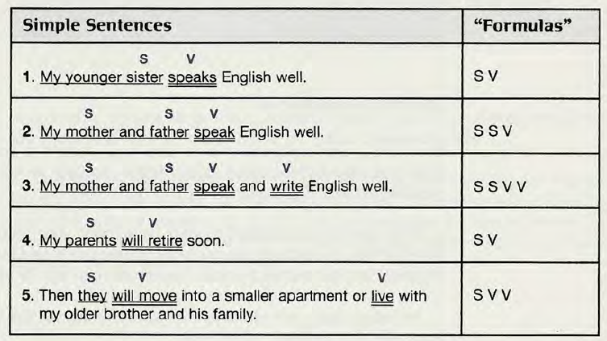
However, each sentence is a simple sentence because it has only one subject-verb pair.
CONNECTIVES
Often you need to connect words or groups of words in a sentence. One way to do this is to use a connecting word. Connecting words are called conjunctions. There are many conjunctions in English. Two of the most common ones are and and or. They have different meanings.
And joins two or more similar things in positive sentences.
e.g.
I like Chinese and Italian food.
We have class on Mondays, Wednesdays, and Fridays.
Or connects two or more similar things in negative sentences.

e.g.
I don’t like warm milk or cold coffee.
We don’t have class on Tuesdays or Thursdays.
Or also connects two or more choices or alternatives.
e.g.
I would like to go to London, Rome, or Paris on my next vacation. (/ cannot go to all three places. I will choose one.)
My father or my mother will meet me at the airport.
(This sentence means that only one person will come to the airport.
Compare:
My father and my mother will meet me at the airport.
(This sentence means that two people will come to the airport.)
COMBINING SENTENCES

Sentence combining is a way to improve your sentence-writing skills. When you do a sentence-combining exercise, you combine two (or more) short sentences into one longer sentence. All the long sentences together make a paragraph.
There may be several correct ways to combine the sentences. However, there are a few rules to follow.
- Don’t repeat words if possible. For example, in the example below, don’t repeat I am.
- You may omit words, but don’t leave out any important information.
- You may change words. For example, you may change a noun to a pronoun or make a singular word plural.
- You may add words. For example, in example 2, you need to add the connecting word and.
Your goal is to write smooth, grammatically correct sentences that contain all the information but do not repeat any of it.
e.g.
- I am a man.
- I am famous.

Combined sentence: I am a famous man.
I am a man and 1 am famous is a grammatically correct sentence, but a native speaker would not write it because a native speaker would not repeat the words I am. Another possible sentence is I am a man who is famous, but this sentence contains unnecessary words.
- I have white hair.
- I have a long white beard.
Combined sentence: I have white hair and a long white beard.
You must keep the word white in the expressions white hair and a long white beard because it is important information.

WRITING PROCESS
Good writing is more than just sitting down and “talking” on a piece of paper. Good writing involves thinking, planning, writing, and revising. You become a good writer by always using these four steps:
- Pre-write to get ideas and organize them.
- Write the first draft.
- Edit: Check and revise your work.
- Write the final copy.
Step 1 Pre-write to get ideas—freewriting.
In the prewriting step, you get ideas to write about. Taking notes is one way to gather ideas. Another way to get ideas is called freewriting. Here is how to do freewriting.
Choose a topic and write it at the top of a piece of paper. Then write whatever sentences come into your mind about the topic. Write horizontally across the paper as you do when you write a letter.

e.g.

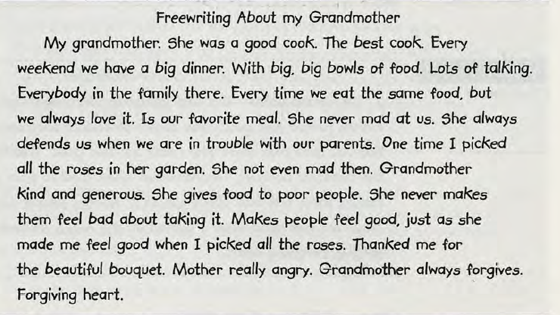

Don't worry about grammar, spelling, or punctuation, and don’t worry about putting your ideas into any kind of order. You don’t even have to write complete sentences. Just write everything that comes into your mind about your topic. If you can’t think of an English word, write it in your own language (NB!). The goal is to keep writing without stopping for about ten minutes or until you run out of ideas.
After you have run out of ideas, edit your freewriting. (Remember that edit means to review and change writing in order to improve it.) Read what you have written and choose one main idea for your paragraph. Cross out ideas that aren’t related to the one main idea.

Step 2 Write the first draft.
In the second step, you write your paragraph in rough form without worrying too much about errors. This first writing is called the first draft or the rough draft.

Step 3 Edit the first draft.
In the third step, you edit your paragraph. When you edit something, you check it and make changes and corrections. Editing is usually a two-step process.

- In the first step, you check the paragraph as a whole. Is the meaning clear?
- In the second step, you check the paragraph for good form, organization, grammar, punctuation, spelling, and so on.
Step 4 Write the final copy.
In the last step, you write a neat final copy of your paragraph to hand in to your teacher.

